**README DOCUMENT MEAL IDEAS APP**

1. Basic Information

--------------------

```markdown

# [Meal Ideas App]

- **Developer**: [Sami EL Naamani]

- **Student Number**: [ST10470683]

- **Group**: [1]

- **Course**: [Higher Certificate in Mobile Application and Web Development]

- **Subject**: [IMAD5112]

## Links

- **GitHub Repository**: [https://github.com/VCSTDN2024/imad5112-assignment-1-SamiST10470683.git]

- **YouTube Video**: [https://youtu.be/iYvCZitDzLY?si=WqAa8u6S2HANhRl_]

```

---

2. Project Overview

-------------------

```markdown

The Meal Ideas App is a mobile application developed as part of an assignment in the IMAD5112 subject. This application was created using **Kotlin** and **Android Studio**. The app's primary purpose is to allow users to input a specific time of day (e.g., morning, mid-afternoon, evening) and receive tailored meal suggestions based on that input.

The app was developed to meet the requirements of the assignment, which includes creating a functional mobile app and utilizing GitHub for version control and CI/CD automation using GitHub Actions.

```

---

3. App Purpose and Features

---------------------------

```markdown

### Purpose:

The main goal of this app is to help users effortlessly decide what to eat based on the time of day and to provide personalized meal suggestions by allowing users to input a specific time—such as morning, mid-afternoon, or evening. The app then generates a list of meal ideas suited to that time, making meal planning convenient and stress-free.

### Key Features:

- Feature 1: The Meal Ideas App offers a tailored meal suggestion feature based on the user's input:

Input: Users specify a time of day (e.g., morning, mid-afternoon, evening).

Output: The app generates a list of meal ideas suitable for that time, including breakfast, snacks, lunch, and dinner options.

Dynamic Suggestions: Meal ideas vary based on the selected time, ensuring relevant and practical options.

User-Friendly Interface: Simple input and clear meal suggestions make the experience seamless and intuitive.

- Feature 2: The Meal Ideas App provides a personalized experience by generating meal ideas based on the selected time of day:

Contextual Meal Suggestions: The app tailors its meal ideas to fit typical eating habits for the selected time, such as breakfast options in the morning and hearty meals in the evening.

Randomized Recommendations: Each time a user selects a time of day, the app generates a unique set of meal suggestions, keeping options fresh and diverse.

Efficient Filtering: The app ensures that meal suggestions are relevant and appropriate for the selected time.

User Engagement: Dynamic, varied options make the app useful for daily meal planning.

- Feature 3: The Meal Ideas App is designed to make meal planning simple and intuitive through seamless user interaction:

Flexible Time Input: Users can select from predefined times of day, such as morning, mid-afternoon, and evening, or manually enter a custom time.

Instant Suggestions: Upon input, the app instantly displays tailored meal options, minimizing wait time.

Interactive Experience: Users can refresh suggestions to explore a variety of meal ideas, adding an element of fun and spontaneity.

These features are designed to provide a user-friendly and enjoyable platform for discovering meal ideas tailored to various times of the day. The Meal Ideas App simplifies meal planning by offering personalised suggestions, reducing decision fatigue, and making it straightforward for users to explore different novel and exciting dishes.

```

---

4. Design Considerations

------------------------

```markdown

## Design Considerations

The **Meal Ideas App** was meticulously crafted based on these key considerations:

1. **User Experience (UX)**: The app’s design prioritised an intuitive and user-friendly interface, aiming for a seamless user experience.

2. **Responsiveness**: The app was meticulously crafted to ensure optimal performance across various screen sizes, with a special focus on device compatibility.

3. **Simplicity**: The design adopts a minimalist approach, prioritising core features without overwhelming the user with excessive complexity.

4. **Performance**: Code optimization was a top priority to ensure fast response times and minimal battery consumption.

```

---

5. GitHub and GitHub Actions Utilization

----------------------------------------

```markdown

GitHub and GitHub Actions:

This project was managed using GitHub for version control. Regularly committed and pushed code changes allowed for collaborative coding, ensuring project integrity.

GitHub Actions was used to automate the build and deployment process. This includes running automated tests to verify app functionality, compiling the app into APK and AAB files for distribution, and uploading these build artefacts to GitHub for easy access.

The workflow automatically builds and tests the project every time changes are pushed, simplifying the process of delivering the final APK/AAB files for submission.

```

---

6. Screenshots and App Demo

---------------------------

```markdown

### App Screenshots:



The opening screen of the app showing the buttons to access the app.

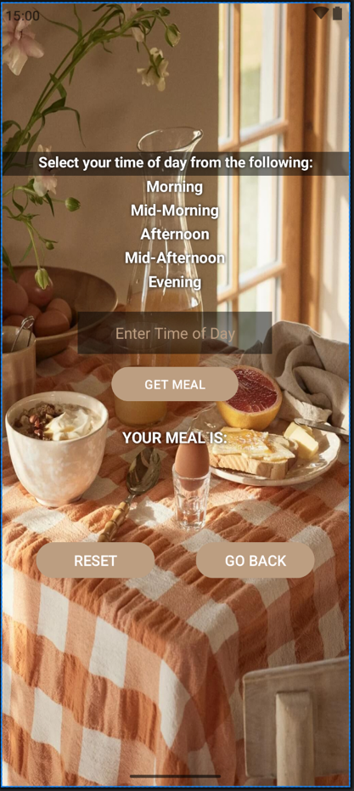

The next page of the app where the user can use the app functionality.

### Video Demo:

A video showcasing the app's functionality can be viewed here: [https://youtu.be/iYvCZitDzLY?si=WqAa8u6S2HANhRl_].

```

---

7. Challenges and Learnings

---------------------------

```markdown

## Challenges and Learnings

During the development of this project, I encountered several challenges, including:

1. **Challenge 1**: Seriously struggled to push the code to the classroom repository.

- **Solution**: I asked my lecturer for help, and we came up with the best solution for the problem.

2. **Challenge 2**: Debugging the initial code in the early days of the app due to an error in the Android Manifest

- **Solution**: Changed the (android:name="") to the correct name.

From these challenges, I learned important lessons in debugging, and pushing the code to the Github repository.

```

---

8. Future Enhancements

----------------------

```markdown

## Future Enhancements

While the current version of the app offers the essential functionality, there are several features that could be added in the future, such as:

1. Custom Meal Plans: Allow users to create, save, and manage personalized meal plans for specific days or weeks.
2. Recipe Integration: Link meal ideas to detailed recipes, including ingredients and preparation steps.
3. Dietary Preferences and Restrictions: Add options for vegan, vegetarian, gluten-free, and other dietary preferences to filter suggestions.

These improvements would enhance the app’s usability and make it even more versatile for users.

```

---

9. References

-------------

```markdown

## References

1. W3Schools, n.d. JavaScript Tutorial. [online] Available at: <https://www.w3schools.com> [Accessed 19 March 2025].
2. The Nordroom, n.d. A Serene Summer House in Sweden. [online] Available at: <https://www.thenordroom.com/a-serene-summer-house-in-sweden/> [Accessed 20 March 2025].
3. [Sonar Systems/Author Unknown], n.d. Map: mapOf Function – Kotlin Programming. [video online] Available at: <https://youtu.be/18h8ZleInKA?si=IHj0X6O-0MEADGZg> [Accessed 25 March 2025].
4. [Android Tutorials Point/Author Unknown], n.d. Display Error Message in Android Studio. [video online] Available at: <https://youtu.be/1vhuwRn9xYE?si=JJO8ybVnwuSxNbr7> [Accessed 25 March 2025].
5. [Tech Projects/Author Unknown], n.d. How to move from one activity to another in android studio on button click | Tech projects. [video online] Available at: <https://youtu.be/JOdWT50bWw4?si=WYjRpKSvAl_6iJGN> [Accessed 25 March 2025].
6. [Polliverse/Author Unknown], n.d. Access UI elements in Android studio. [video online] Available at: <https://youtu.be/fUAi_RCCNIg?si=MVpZ6manAeX-KcgI> [Accessed 26 March 2025].
7. [Rami Wahid/Author Unknown], n.d. Make simple exit button in android studio. [video online] Available at: <https://youtu.be/Yx63M4k-EeE?si=nP31E2SQISxRnZHZ> [Accessed 27 March 2025].
8. [DJ Malone/Author Unknown], n.d. Android Tutorial: findViewById and setOnClickListener(). [video online] Available at: <https://youtu.be/Cw3F7NeaI3I?si=AM1wfIaBfORFwNcm> [Accessed 25 March 2025]

```

---

10. List of Figures

-------------------

```markdown

## List of Figures

- **Figure 1**: 

Screenshot of opening page of app.

- **Figure 2**: 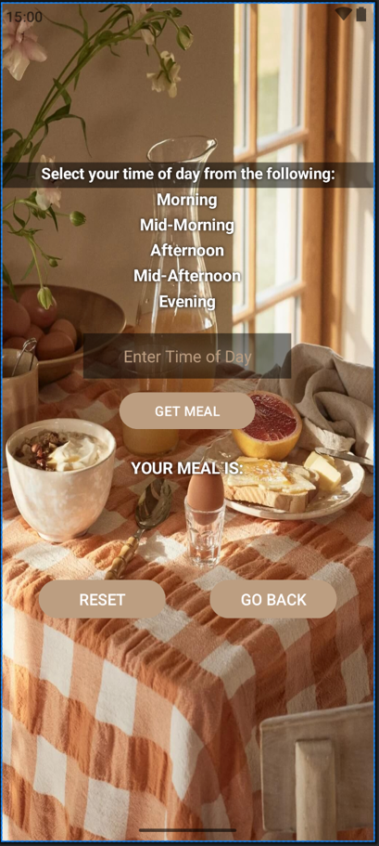

Screenshot of user input page.

```

---